OS & SP
Name : D Teja Sadwika Roll No : 2520030536
Practical – 06
Server.c
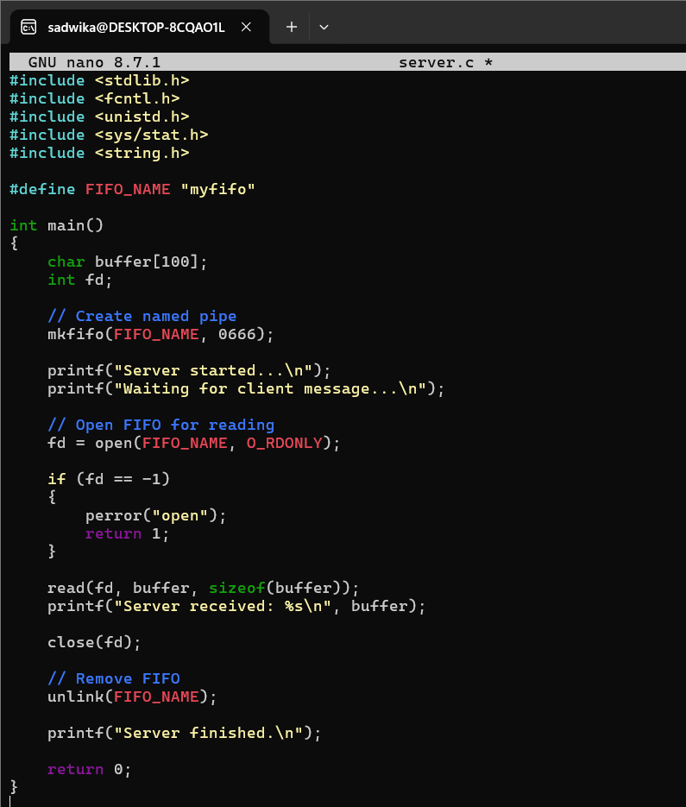
Client.c
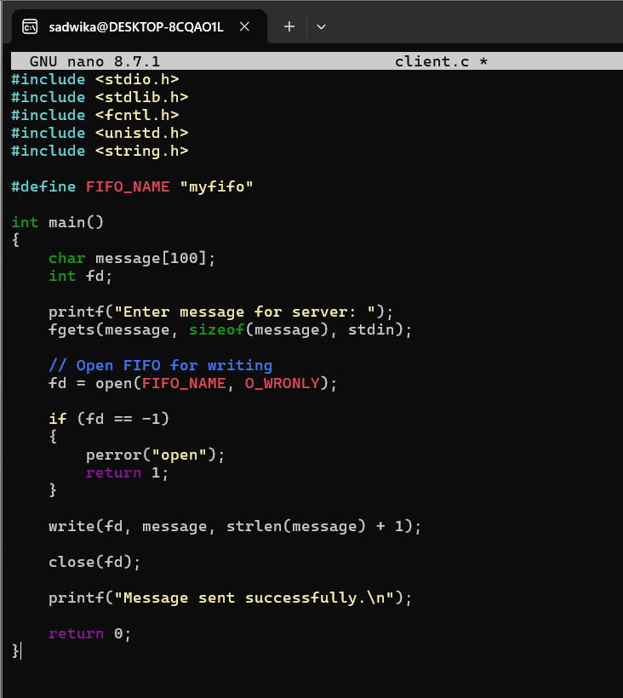

Output :
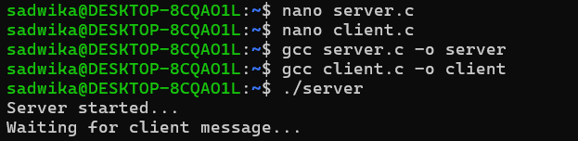
Signals.c
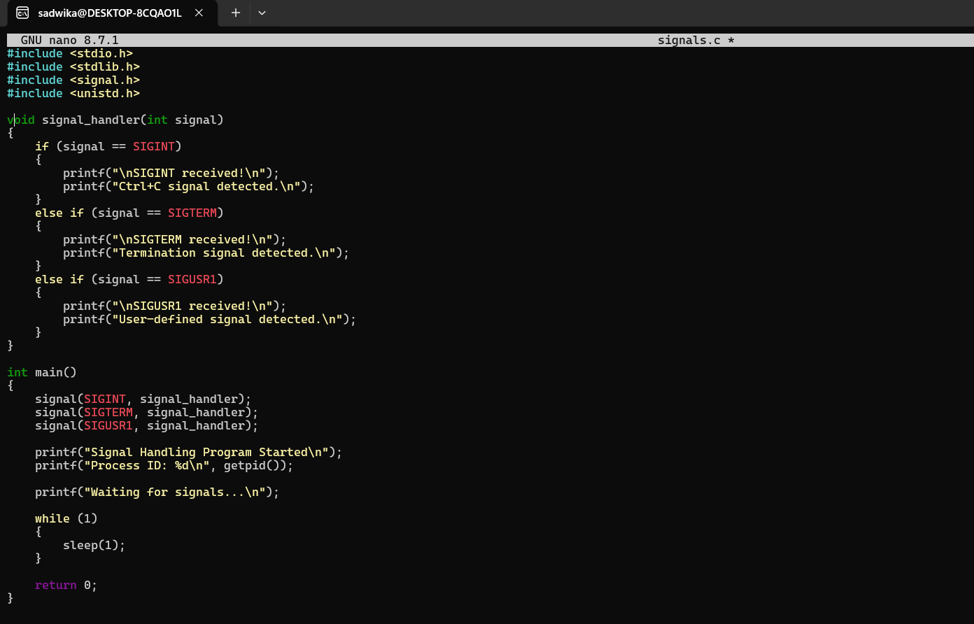
Output :
